Barcode Scanner Based Point of Sale System

Sandesh Chinchole, Ajinkya Datalkar, Vijay Pawar, Sujal Patel, Siddhant Shinde

Seidenberg School of Computer Science and Information Systems

Pace University, New York, NY, USA

*Abstract*— Managing a retail store efficiently in this day and age has become quite cumbersome. The store manager has to juggle numerous issues and come up with solutions to tackle these issues. The Point of Sale system presented in the paper uses a multiplatform desktop application, an Android application along with a database server, internet connection and a router to help manage the store remotely. Identifying store items with a barcode scanner, completing retail transactions and generating bills are the three main tasks performed by the system. The system can be configured to either run as a centralized system or as a distributed system. The Point of Sale system also managed to demonstrate the important characteristics of high efficiency, platform independence and being user-friendly.

*Index Terms*— Barcode Scanner, Point of Sale, Point of Purchase, Centralized System, Distributed System.

# INTRODUCTION

The Point of Sale (POS) or Point of Purchase (POP) is the time and place where a retail transaction is completed. At the Point of Sale, the merchant calculates the amount owed by the customer, indicates that amount, may prepare an invoice for the customer (which may be a cash register printout), and indicates the options for the customer to make payment. It is also the point at which a customer makes a payment to the merchant in exchange for goods or after the provision of a service. After receiving the payment, the merchant may issue a receipt for the transaction, which is usually printed but is increasingly being dispensed with or sent electronically.

Typically, the process of purchasing items from a store is pretty straightforward. The customer places the items he wants into his cart and carries it to the checkout counter. At the checkout counter, the cashier scans the barcode of each item with help of a barcode scanner, the billing system generates a bill for all the items and finally, the customer makes a payment with his preferred mode of payment. The system described in this article goes about the same process in a different way. The POS system uses a multi-platform desktop application, an Android application, database server, internet connection, and a router. The system can be used in 4 steps to manage a certain store. First, a database needs to be created which includes information regarding every item that is for sale in the store. The second step is to generate a barcode sticker for each item using the print label screen of the application. The generated barcode stickers are then applied to the item. When customers intend to purchase items from a store using our system, they bring the items to the store’s checkout counter. Step 3 is to scan the item barcode using our system’s Android application. The Android application activates the phone’s camera to scan barcodes. When the item barcode is scanned, an entry for that particular item is made in the desktop software. Finally, a bill is generated for all the items scanned via the Android application. Bill generation is part of step 4 which also includes tax calculation and presenting the customer with payment options for purchasing the items from the store.

The POS system has multiple advantages over the widely used traditional systems. The POS system can be configured to act as a centralized or as a distributed system, according to the requirements of the store manager or owner. POS system is cost-effective because it makes use of an Android application to scan barcodes thus saving the cost of buying a separate barcode scanning equipment. The cross-platform nature of the POS desktop application is also one of its unique features. The POS system will be used in stores that sell dry fruits, chocolates, cookies, chips, and various other items. The price of most of the items will depend on the weight of the item. The software will be developed using C++, JavaScript, CSS, HTML, PHP, and QML. Finally, we will be creating the installer for the software using NSIS.

# Related Work

A significant quantity of research on a similar subject has been done before. One such work demonstrates a POS system transaction server application [1] which handles the communication between itself and the POS application, including that relayed from the application, and with the bank system. The link between the application and the transaction server is relayed via the POS PC. The transaction server application controls the communication between the transaction server and the POS application. In POS application we are using the Cryptography Hash function for safe and secure transaction. Automated purchasing control system [2] is another research work in the same domain. The basic purpose of the POS transaction system is to support an authorization for credit card or debit card. This task is performed via an electronic connection Our approach is to use wireless POS integration that uses wireless POS computer with installed card reader, for encrypted transaction it uses the pin encryption which is configured with the POS system on PC. This connection will be successfully adopted by establishing a connection with the LAN between the POS system and Transaction process equipment.

Finally, POS System [3] was the last major research work that was referred for our system. Barcode technique has been widely used to identify products, goods or deliveries in our daily life. Usually, barcode readers are devices with laser-scanners to decode the printed images. In recent years, digital cameras become cheaper, portable and widely available to personal devices such as smartphones. It would be convenient if barcode image can be decoded by using these digital camera equipped personal devices. However, as with other image processing tasks, it remains a challenge to recognize barcode with high accuracy under difficult conditions. Barcode reading is usually decomposed into two steps and they are Identifying the location of the barcode area in the given image and decoding the target area according to the barcode encoding rules.

# Proposed Work

Apart from generating bills and completing retail transactions one of the most important jobs of the point of sale system is to make things easier for the store owner and his employees. This can be done by simply understanding the requirements of the store owner and his employees. Basic requirements of a point of sale system are to complete retail transactions, keep track of inventory and generate and keep a record of bills. Additional features such as barcode generation, sales reports, profit and loss statements, employee records and taxation can also be added to the system. This way the store owner has to learn to work with one system that manages everything for him.

The system is completely personalized depending upon the type of employee logging into the system. The system being developed is cross-platform and can be accessed from all types of devices. For example, if the store owner logs into the system he will be taken to the screen that shows all types of reports related to sells, inventory, and employees. If a cashier logs into the system, he will be taken to the billing screen and if an employee who helps customers finding the product or helps to get details of the product, will log in from a mobile device and will be taken to a screen that scans for barcodes and display product information such as price, company, expiry and its location in the store. The system allows two types of configurations and they are as follows:

### Centralized System:

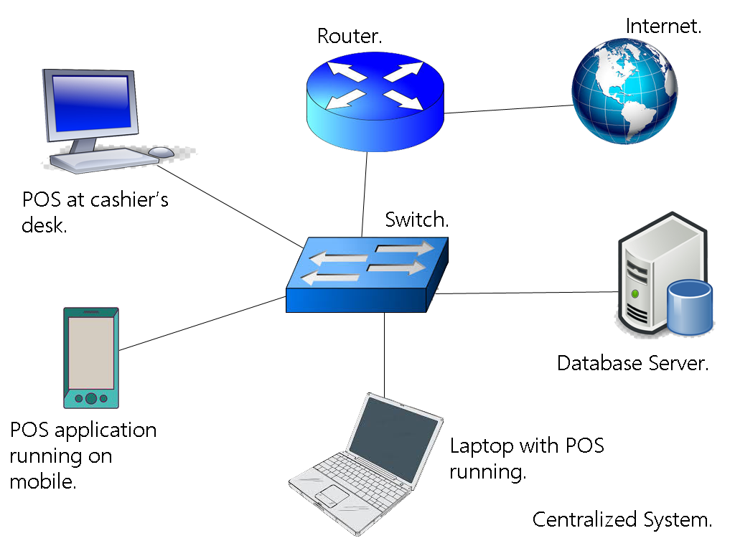

Fig. 1. Centralized System Overview

In a centralized system as shown in Fig.1, the database server is present locally. The system can work even if there is no internet connection. Local DNS is configured in the router and this allows the POS software and the mobile application to access data from the server. The Barcodes generated are at the server side and then transmitted over HTTP in plain text format.

### Distributed System:

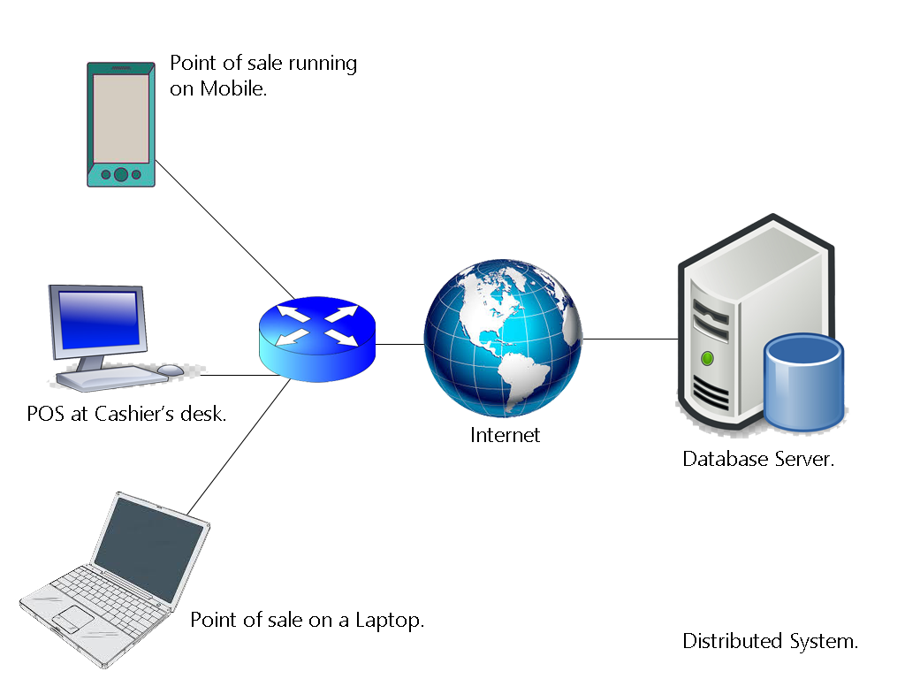

Fig. 2. Distributed System Overview

In a distributed system as shown in Fig.2, the database server is present remotely and has to be accessed over the internet. This type of system is suitable for a chain of shops. There’s no local DNS and extra security measures are required to be taken.

# Implementation

We are developing the software using C++, JavaScript, HTML, CSS, PHP, and AJAX. The main window of the software is written in C++. The function of the main window is to allow the users to Login, Register and allow user administration. The software verifies data from the database via the server-side pages written in PHP. Depending upon the type of user logging in, the main window redirects the user to the required screen. For example, a cashier after logging in will be redirected to the Billing screen and the owner of the store after logging in will be redirected to the screen that shows reports. Using server-side scripting makes it easier for us to connect cross-platform applications to the database. The Android application is being developed in JAVA using android-studio. We are using 128-bits barcodes.

# Results

This system basically performs three main tasks and they are Identifying store items with a barcode scanner, completing retail transactions and generating bills. Bill generation also includes tax calculation and offering multiple modes of payment options to the customer. Barcode scanning is done via the Android application and barcode labels are generated using the print label screen of the desktop application. The system can be configured to be run as a centralized or as a distributed system. The various screens of the application demonstrate the different features of the POS system.

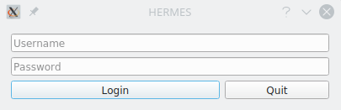

Fig. 3. Login Window

The login window shown in Fig.3 ushers the user into the system. It consists of two input fields and two buttons. The first field prompts the user to enter a username. The second field prompts the user to enter a password. After the login credentials are verified, the user is granted access to the Point of Sale system. Finally, upon clicking the quit button, the username and password fields are reset, and the system shuts down.

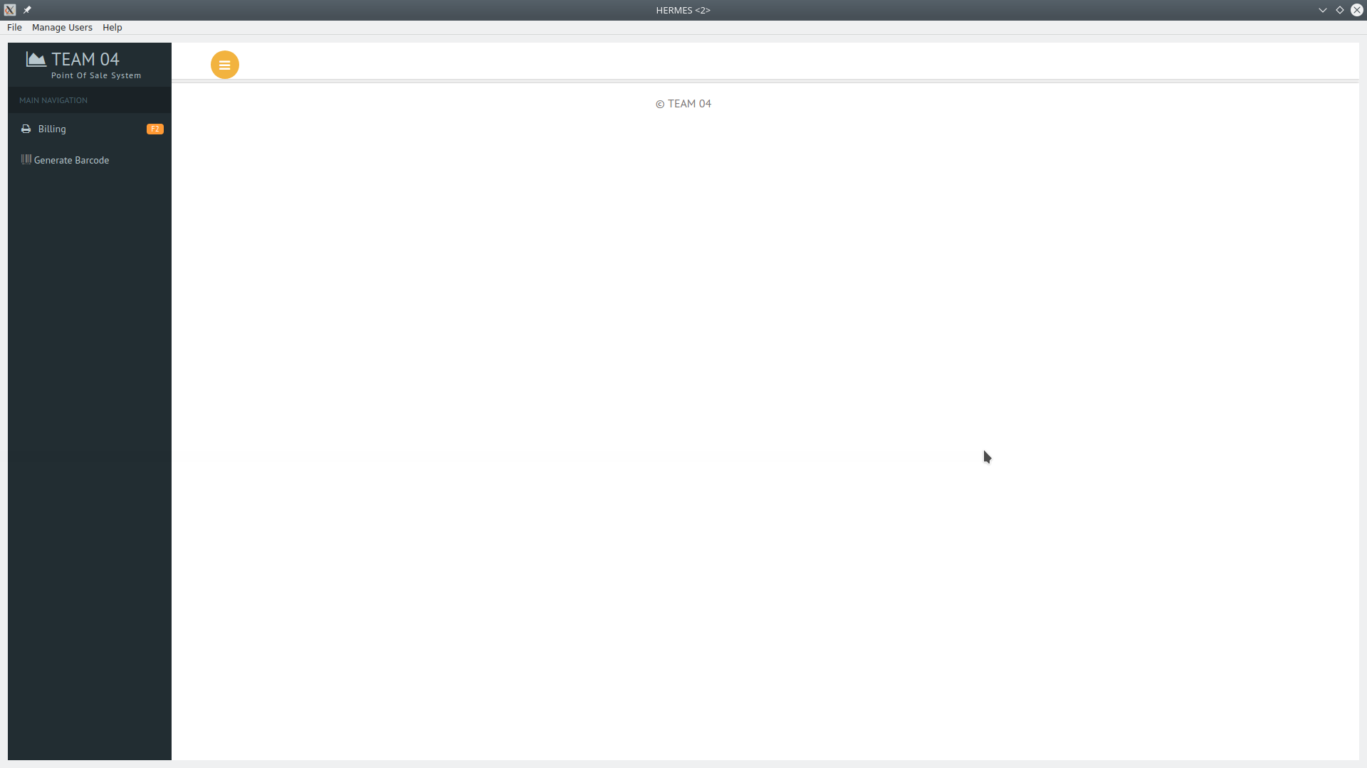

Fig. 4. Main Screen

The Main Screen shown in Fig.4 consists of three tabs at the moment. The File tab is used for file management. The Manage Users tab is used for managing the users of the system. The Help tab displays various help options to the user so as to make it easier for the user to use the system.

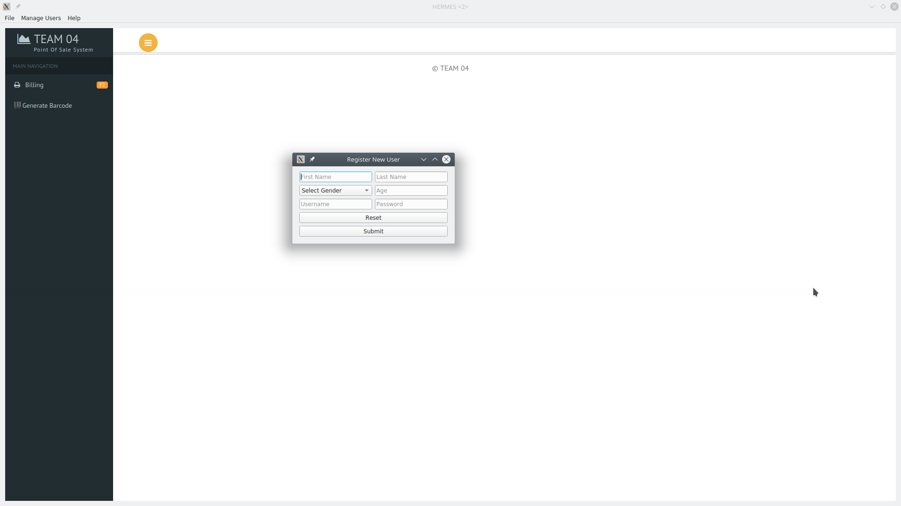

Fig. 5. Register New User Screen

Registering new users into the system is done via the Register New User screen as shown in Fig.5. This screen has multiple fields to enter data about the new user. There are two buttons at the bottom of the screen. The Reset button resets the data entered in the data fields whereas the Submit button submits the data entered in the fields.

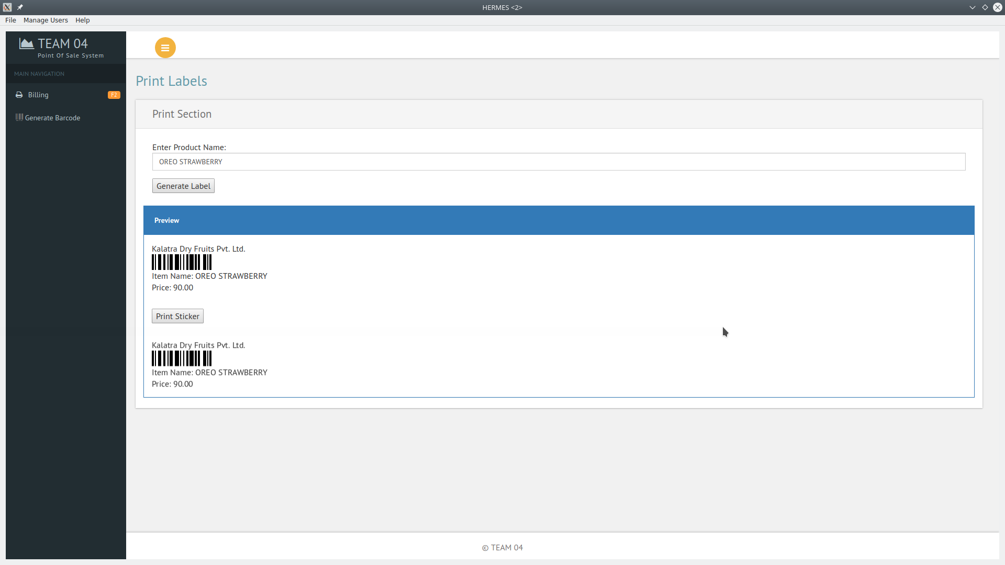

Fig. 6. Print Label Screen

Generating barcode-based labels for store products and printing them is done via the print label screen as shown in Fig.6. The printed labels are then glued on the various store products to easily identify them for billing purpose.

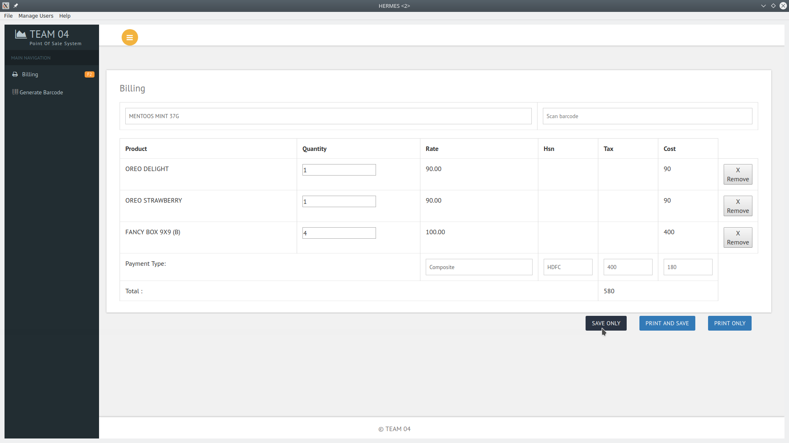

Fig. 7. Billing Screen

Fig.7 shows the billing screen of the application where bills for products purchased from the store are generated. The billing screen also displays item quantity, cost, tax, total bill and payment options.

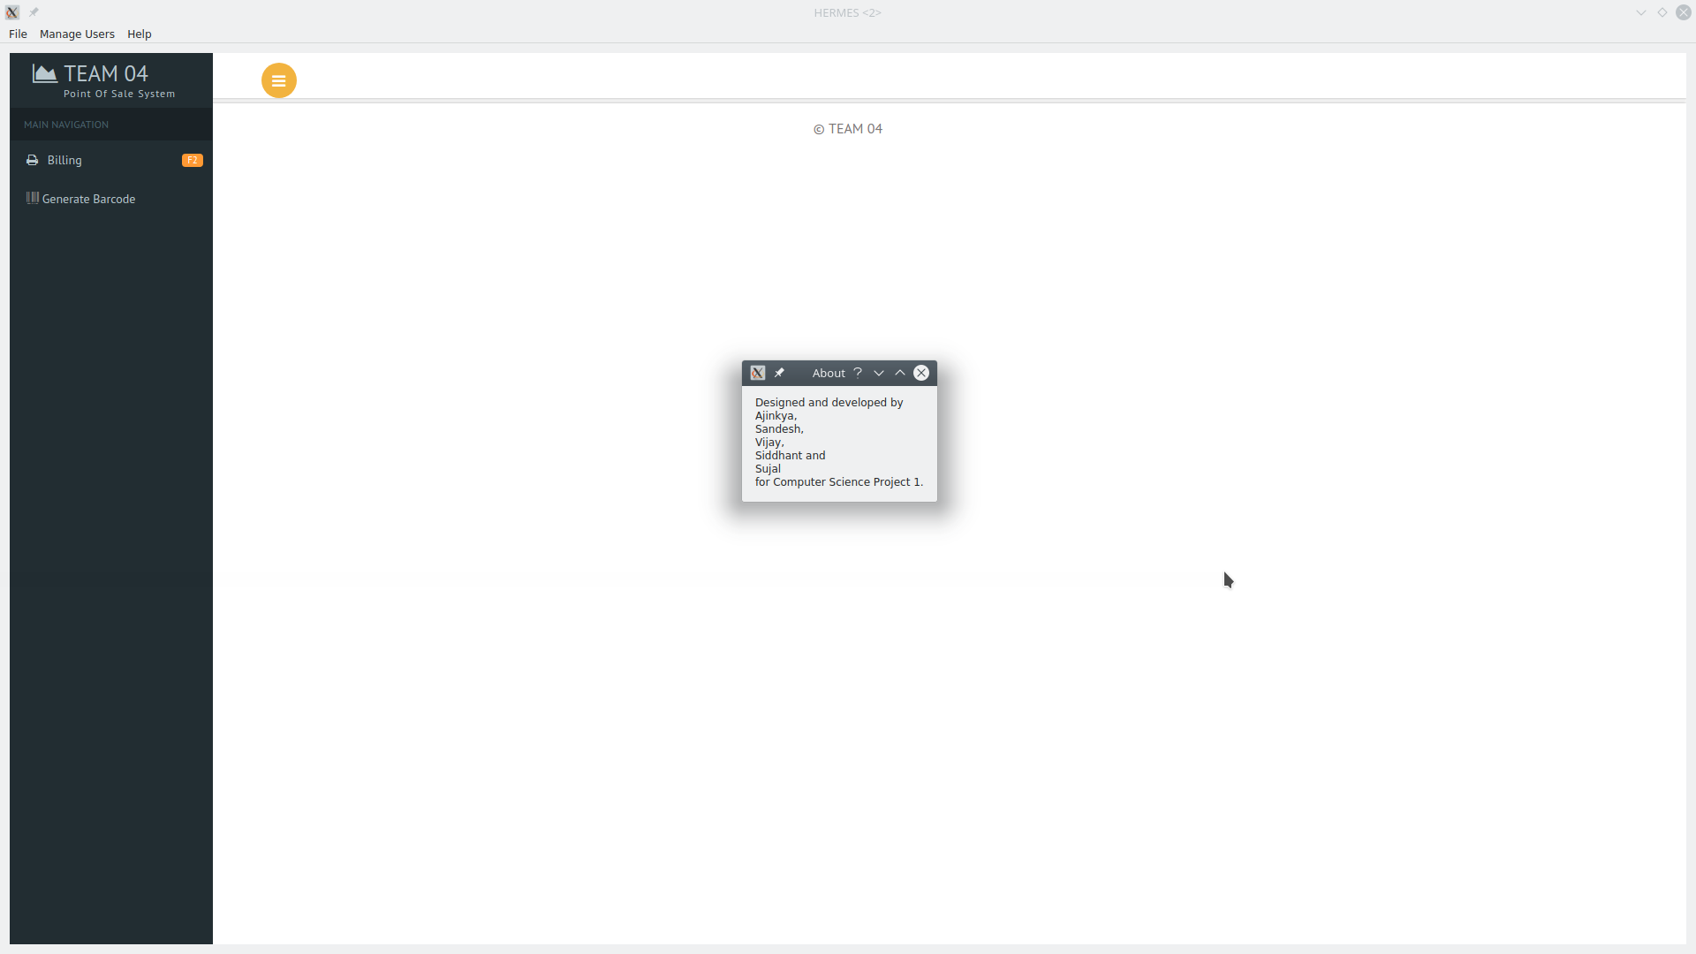

Fig. 8. About Window

The About window shown in Fig.8 displays the names of the team members behind this system and the name of the Pace University course for which this project has been developed.

# Conclusion

This paper discussed the design and development of a smart Point of Sales system which runs on multiple devices and can be configured according to the requirements of a particular store. The system performed three main tasks of generating bills and completing retail transactions. The approach discussed in the paper achieved our goal of making it easier for the store owner and his employees to manage their store efficiently. Future research work involves integrating features such as sales reports, profit, and loss statements and employee records into the system. Additionally, there are plans to release this software on iOS and web platforms, making the system even more accessible.

References

[1] Z. Fred and S. Verne, “Unattended POS System for automatic control of bank system rejections”, U.S. Patent 6 092 057, Jul. 18, 2000.

[2] L. Stephen and G. Laurence, “Automated purchasing control system”, U.S. Patent 5 621 201, Apr. 15, 1997.

[3] S. Makoto and I. Tatsuyuki, “POS System”, U.S. Patent 4 855 908, Aug. 8, 1989.

[4] L. Adam and J. Stephen, “Scanner pairing in a Bluetooth POS network”, U.S. Patent 6 783 071 B2, Aug. 31, 2004.

[5] B. Stuart, “Delivery Management System for Quick Service Restaurants”, U.S.  Patent 0 048 890 A1, Feb. 19, 2009.

[6] E. Shigeki and S. Kazuhito, “POS system with customer terminal”, U.S. Patent 5 734 839, Mar. 31, 1998.

[7] S. Jhon and I. Donald, “Automated purchase reward accounting system and method”, U.S. Patent 5 056 019, Oct. 8, 1991.

[8] G. Richard and E. Thomas, “Point of sale system”, U.S. Patent 0 283 436 A1, Dec. 22, 2005.

[9] J. Emmanuel and R. Elizabeth, “Self-Checkout system for bypassing in store checkout”, U.S. Patent 0 068 374, Mar. 8, 2018.

[10] O. John and R. Jordan, “Automated delivery system of a cosmetic sample”, U.S. Patent 0 206 612, Jul. 26, 2018.